- Capture and analyze ARP packets using Wireshark. Inspect the ARP request and reply frames, and discuss the role of the sender's IP and MAC address in these packets.
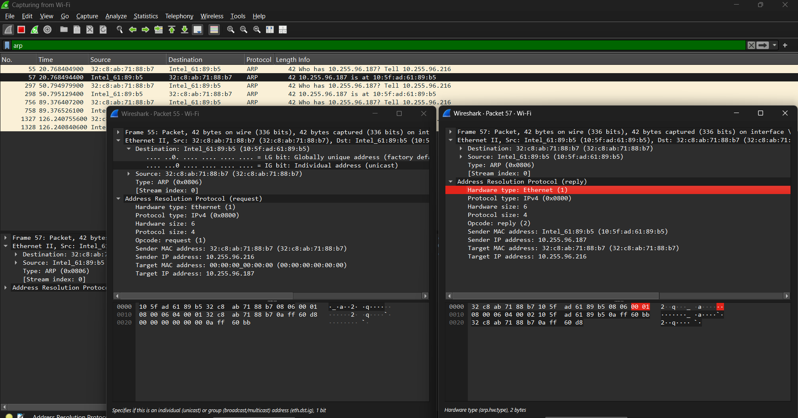

- Using Packet Tracer, simulate an ARP spoofing attack. Analyze the behavior of devices on the network when they receive a malicious ARP response. 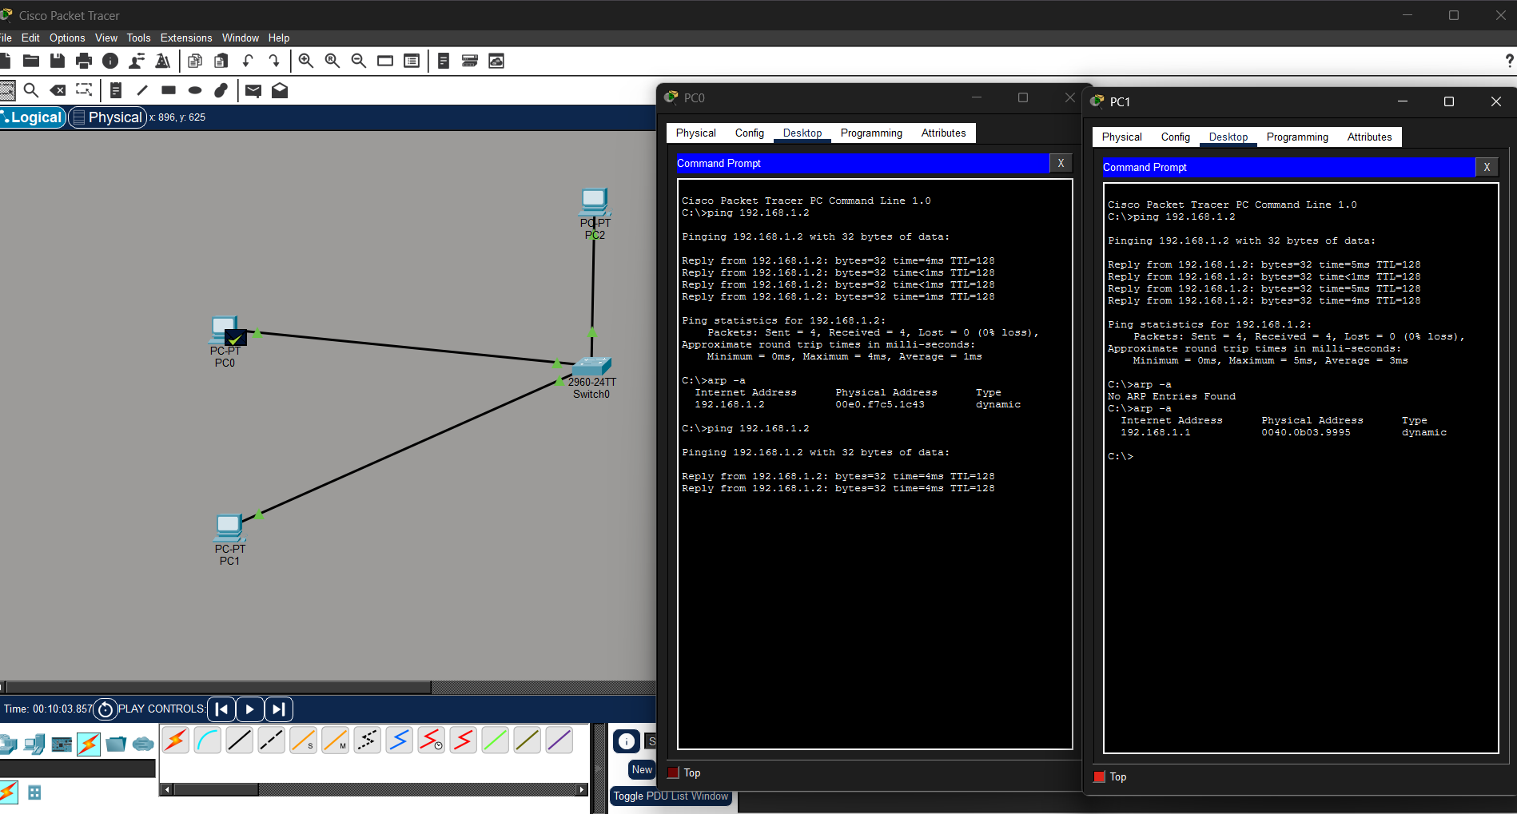

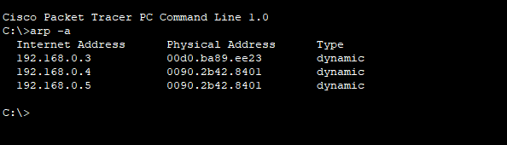
- Manually configure static IPs on the client devices(like Pc or your mobile phone) and verify connectivity using ping.
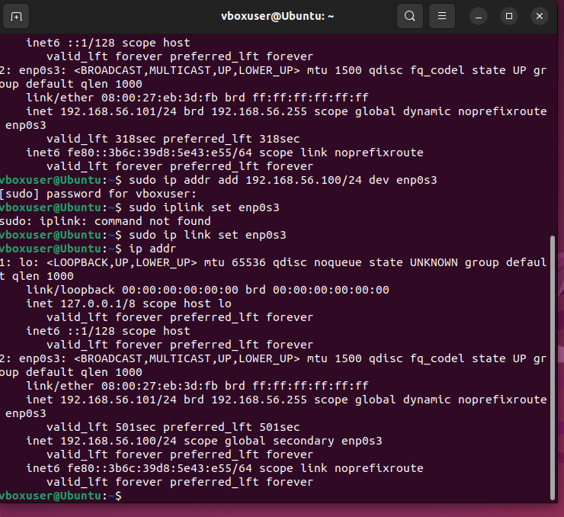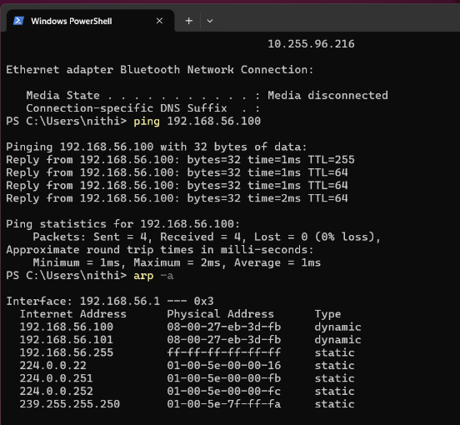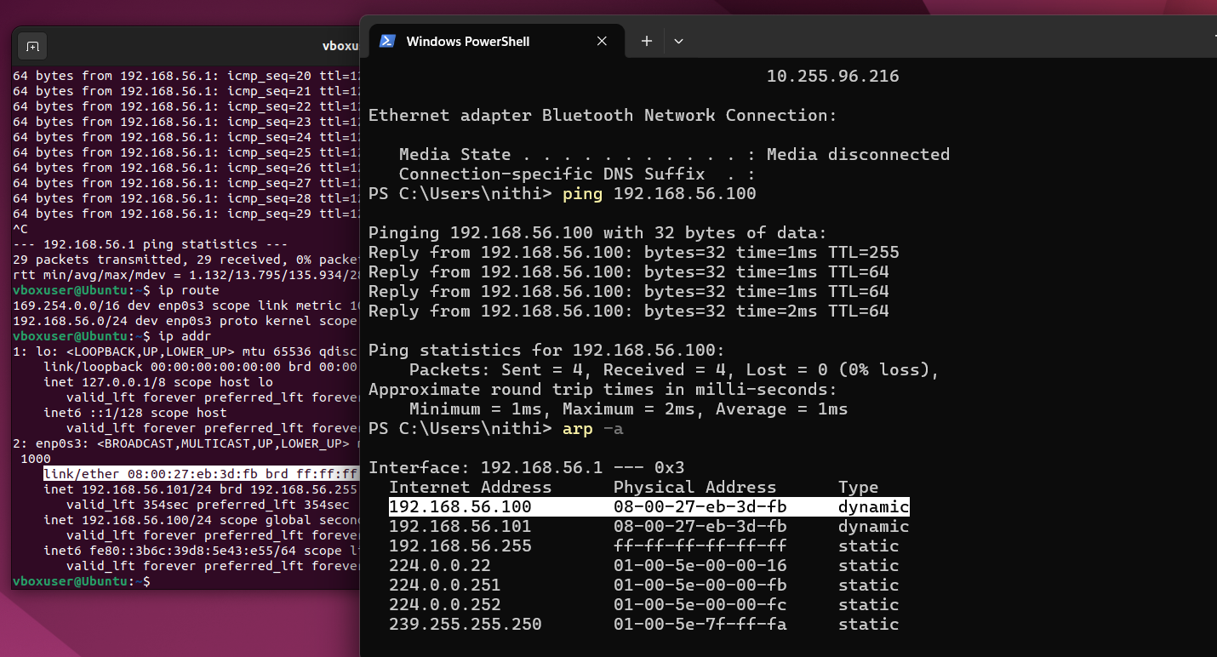

- Use Wireshark to capture DHCP Discover, Offer, Request, and Acknowledge messages and explain the process.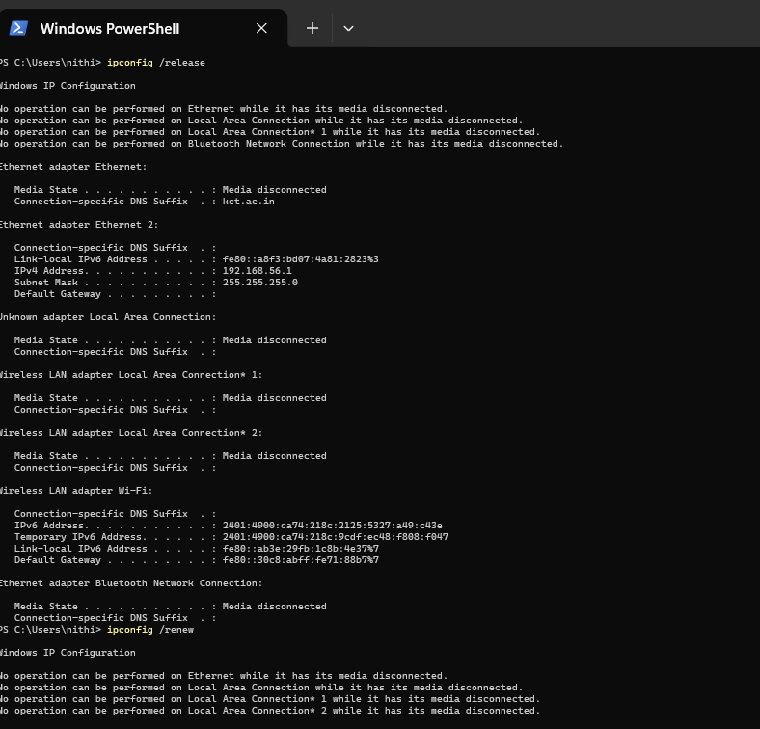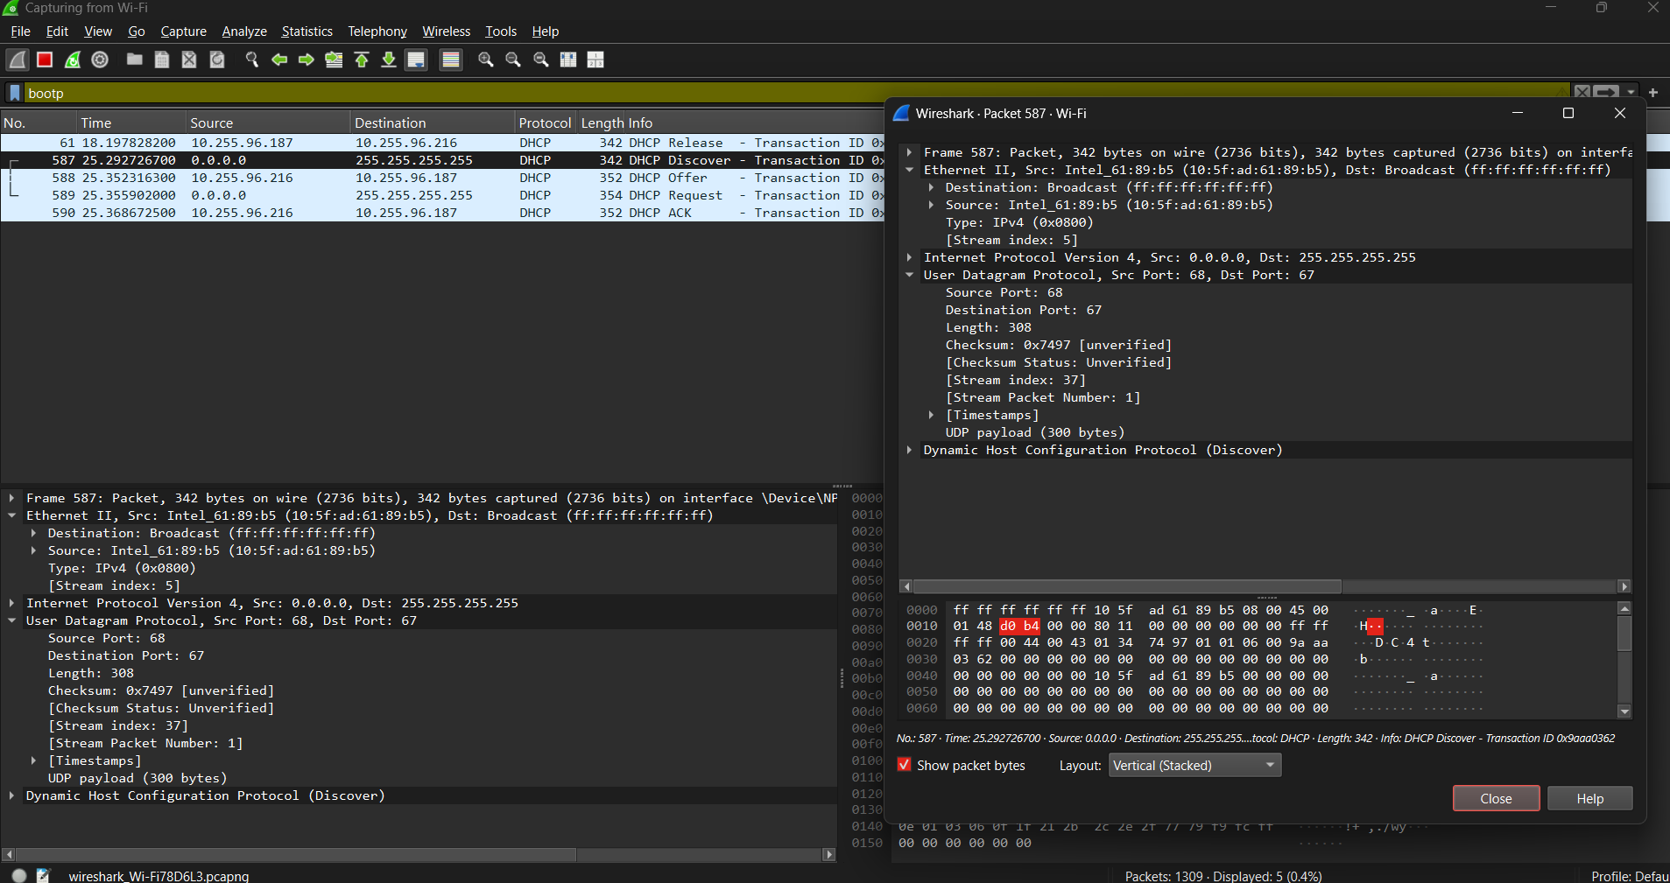

- Given an IP address range of 192.168.1.0/24, divide the network into 4 subnets.
Task: Manually calculate the new subnet mask and the range of valid IP addresses for each subnet.
- IP: 192.168.1.0
- Subnet mask: /24 → 255.255.255.0
- Total hosts in /24: $2^{32-24}-2=254$hosts
Step 2: Determine the new subnet mask
We need 4 subnets.
Formula:
$$\text{Number of subnets}=2^{n}$$Where n = number of bits borrowed from host portion.
- 2² = 4 → borrow 2 bits from host part
- New subnet mask:
$$/24+2=/26$$
- /26 → 255.255.255.192
  - Subnet increment: 256 − 192 = 64
Step 3: Calculate the subnets
Start from 192.168.1.0, increment by 64 in the last octet:
Subnet | Network Address | First Host | Last Host | Broadcast Address
1 | 192.168.1.0/26 | 192.168.1.1 | 192.168.1.62 | 192.168.1.63
2 | 192.168.1.64/26 | 192.168.1.65 | 192.168.1.126 | 192.168.1.127
3 | 192.168.1.128/26 | 192.168.1.129 | 192.168.1.190 | 192.168.1.191
4 | 192.168.1.192/26 | 192.168.1.193 | 192.168.1.254 | 192.168.1.255
✅ Each subnet has:
- 64 addresses (62 usable for hosts)
- Network + Broadcast addresses reserved
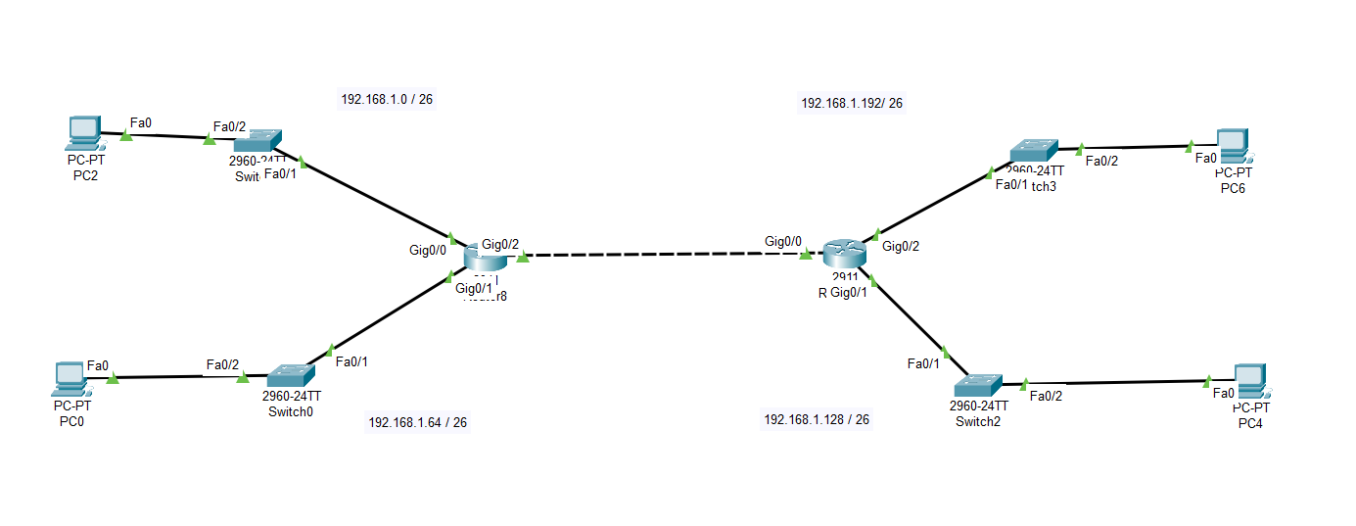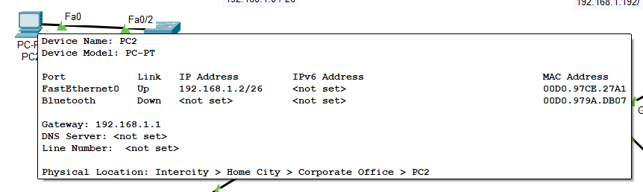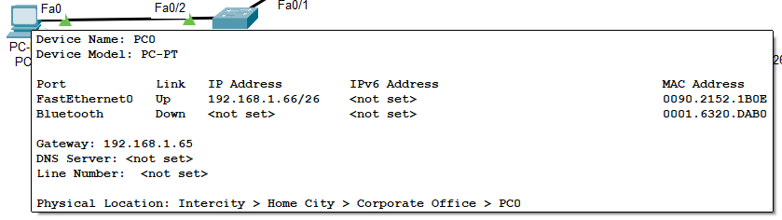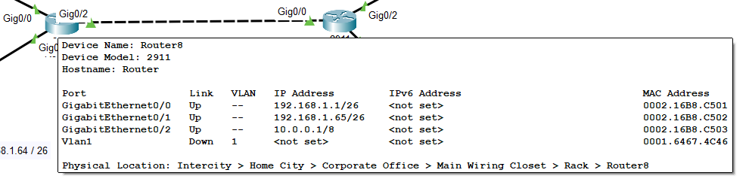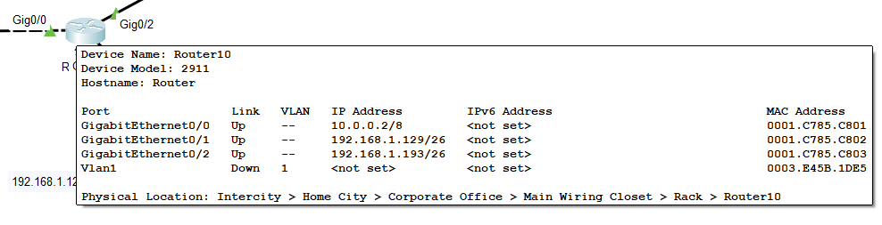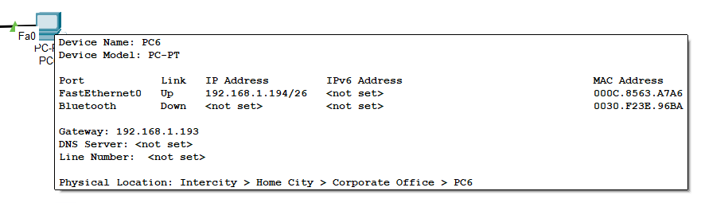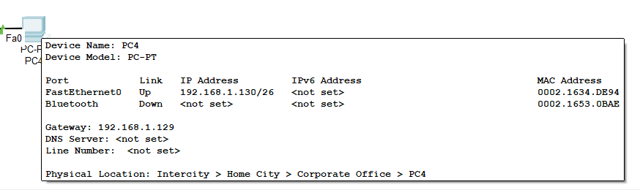
Final Ping results after implementation..
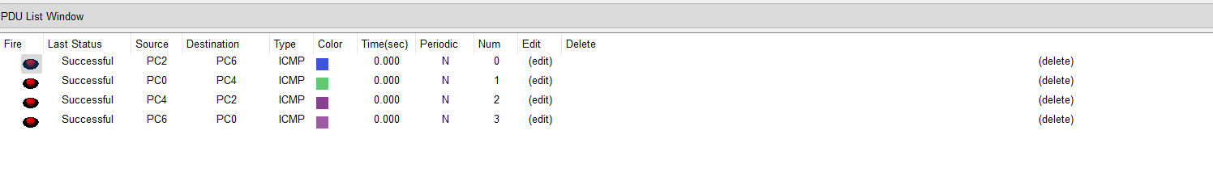

- You are given three IP addresses: 10.1.1.1, 172.16.5.10, and 192.168.1.5. Task Identify the class of each IP address (Class A, B, or C). What is the default subnet mask for each class? Provide the range of IP addresses for each class.
Class | First Octet Range | Default Subnet Mask | Number of Networks | Number of Hosts per Network
A | 1 – 126 | 255.0.0.0 | 128 | 16,777,214
B | 128 – 191 | 255.255.0.0 | 16,384 | 65,534
C | 192 – 223 | 255.255.255.0 | 2,097,152 | 254
Special notes:
Check each IP
(a) 10.1.1.1
- First octet = 10 → falls in 1 – 126 → Class A
- Default subnet mask = 255.0.0.0
- Range of Class A addresses:
Network: 10.0.0.0
Usable Hosts: 10.0.0.1 – 10.255.255.254
Broadcast: 10.255.255.255
✅ This IP is Class A private IP.

(b) 172.16.5.10
- First octet = 172 → falls in 128 – 191 → Class B
- Default subnet mask = 255.255.0.0
- Range of Class B addresses:
Network: 172.16.0.0
Usable Hosts: 172.16.0.1 – 172.16.255.254
Broadcast: 172.16.255.255
✅ This IP is Class B private IP.

(c) 192.168.1.5
- First octet = 192 → falls in 192 – 223 → Class C
- Default subnet mask = 255.255.255.0
- Range of Class C addresses:
Network: 192.168.1.0
Usable Hosts: 192.168.1.1 – 192.168.1.254
Broadcast: 192.168.1.255
✅ This IP is Class C private IP.

3. Summary Table
IP Address | Class | Default Subnet Mask | Private IP Range
10.1.1.1 | A | 255.0.0.0 | 10.0.0.0 – 10.255.255.255
172.16.5.10 | B | 255.255.0.0 | 172.16.0.0 – 172.31.255.255
192.168.1.5 | C | 255.255.255.0 | 192.168.0.0 – 192.168.255.255

- In Cisco Packet Tracer, create a small network with multiple devices le.g., 2 PCs and a router). Use private IP addresses (e.g., 192.168.1.x) on the PCs and configure the router to perform NAT to allow the PCs to access the internet.
Task: Test the NAT configuration by pinging an external IP address from the PCs and capture the traffic using WiresharWhat is the source IP address before and after NAT?

Router Configuration (NAT)
enable
configure terminal
interface g0/0
ip address 192.168.1.1 255.255.255.0
ip nat inside
no shutdown
interface g0/1
ip address 200.0.0.1 255.255.255.0
ip nat outside
no shutdown
access-list 1 permit 192.168.1.0 0.0.0.255
ip nat inside source list 1 interface g0/1 overload
exit
write memory

